1. Ankit is in maze. The command center sent him a string which decodes to come out from the maze. He is initially at (0, 0). String contains L, R, U, D denoting left, right, up and down. In each command he will traverse 1 unit distance in the respective direction. For example if he is at (2, 0) and the command is L he will go to (1, 0).

Input: Input contains a single string.

Output: Print the final point where he came out

Example Input : LLRDDR

Example Output : 0 -2

2. Given n positive integers, find the minimum and maximum values that can be calculated by summing exactly n-1 of the n integers. Then print the respective minimum and maximum values as a single line of two space-separated long integers.

For example, arr=[1,5,3,7]. Our minimum sum is 1+3+5 = 9 and our maximum sum is 3+5+7 = 15. We would print

9 15

Input : The first line is the number of test cases, T The first line of each test case is n The second line of each test case are the space separated n-values of arr

Output : Space separated values minimum and maximum

3. Given an NxN 2-D array, find the sum of all the sub-matrices.

Input : First line is the number of test cases, T Second line contains the number N Next N lines are the values of the matrix(each row - space separated)

Output : Output the sum

4. Generate a simple Floyd triangle for the given value of n lines. A Floyd traingle looks like this(ex: for n=4)

1

2 3

4 5 6

7 8 9 10

Input : The first line is T and only line of each test case is n

Output: Print the Floyd triangle.

5. Determine if a given string has all unique characters.

Input : The first line is T and only line in each test case is the string S.

Output : “Yes” if it does have all unique characters and “No” if it doesn’t.

6. Given below is a picture of a 7-segment display :

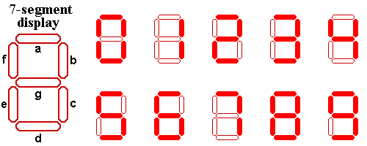

Alice got a number written in seven segment format where each segment was created using a matchstick.

Example: If Alice gets a number 123 so basically Alice used 12 matchsticks for this number.

Alice is wondering what the numerically largest value that she can generate by using at most the matchsticks that she currently possesses.Help Alice out by telling her that number.

Input : First line is the number of test cases, T First line of each test case consists of a number N which is the number of matchsticks

Output : The largest possible number that can be formed using the N matchsticks

Example Input : 1 8

Example Output : 91

Explanation : 6 matches are required for creating 9 and 2 matchsticks for 1.

7. A football competition has just been conducted and it is your job to find out the person with the highest ranking. You are given two sequences A1,A2,…,AN and B1,B2,…,BN. For each valid i, player i scored Ai goals and committed Bi fouls. For each goal, the player that scored it gets 20 points, and for each foul, 10 points are deducted from the player that committed it. However, if the resulting number of points of some player is negative, this player will be considered to have 0 points instead.

Input: The first line is the number of test cases, T The first line of each test case is the space separated values Ai The second line of each test case is the space separated values Bi

Output : Output the highest score of a candidate

8. You have been asked to help study the population of birds migrating across the continent. Each type of bird you are interested in will be identified by an integer value. Each time a particular kind of bird is spotted, its id number will be added to your array of sightings. You would like to be able to find out which type of bird is most common given a list of sightings. Your task is to print the type number of that bird and if two or more types of birds are equally common, choose the type with the smallest ID number.

For example, assume your bird sightings are of types arr=[1,1,2,2,3] . There are two each of types 1 and 2 and one sighting of type 3 . Pick the lower of the two types seen twice: type 1.

Input : The first line is the number of test cases, T 1st line of each test case is the number of birds sighted N 2nd line of each test case is the array arr as space separatedN-values

Output: Print the type number of the most common bird; if two or more types of birds are equally common, choose the type with the smallest ID number.

9. Two players are playing a game in which both players are given the same string.Both players have to make substrings using the letters of the string .Stuart has to make words starting with consonants.Kevin has to make words starting with vowels. The game ends when both players have made all possible substrings. A player gets +1 point for each occurrence of the substring in the string

Ex: String = BANANA Kevin's vowel beginning word = ANA

Here, ANA occurs twice in BANANA. Hence, Kevin will get 2 Points.

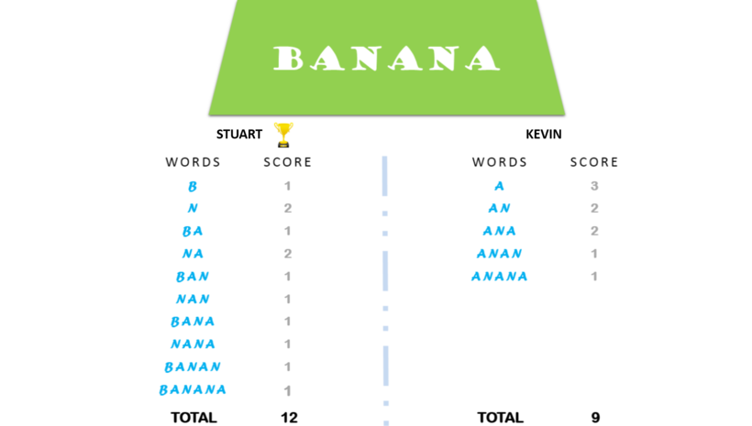

Input : The first line is the number of test cases and only line in each test case is the word.

Output : Output the name of the winner(one with highest points) space separated with the number of points scored by him.

10. Consider a permutation of length N such that P[i] = P[P[i]]. You are given an array P such that elements of the array are in random order from 1,2,...N. Find the least number of such permutations required so that the array becomes an identity matrix, meaning P=[1,2,3,....,N]

Input : The first line is the number of test cases and first line of each test case is the array P.

Output: The least number of such permutations to get an identity matrix.

11. X has invested in N coins. Every ith coin, has value Ai. But X cannot remember value of each coin and so he decides to remember the arithmetic mean of the coins. You have decided to steal one of the coins from X such that X does not find out about it. So, you ensure that the arithmetic mean remains the same even after stealing the coin.

Input : The first line consists of the number of test cases,T The first line of each test case is number N The second line of each test case are space separated values Ai

Output : If it is possible to successfully steal a coin without X finding out, output i, the ith coin that you successfully steal. If it is impossible to steal a coin without X finding out, output the string “Impossible”(without quotes)

12. Create a fibonacci word sequence using words W and X given to you. It is similar to forming the Fibonacci number sequence 0,1,1,2,3,5… but instead of starting off with 0 and 1, you start with W and X using string concatenation. Given W, X and n, you are supposed to find the nth Fibonacci word using W and X

Input : First line is number of test cases First line of each test case is n Second line of each test case is space separated strings W and X

Output : Output the nth Fibonacci word

Ex : W = hey ; X = hi and n=5

W,X,WX,XWX,WXXWX

Output : heyhihiheyhi

13. There are n houses in a city called Mitsone, numbered from 1 to n. Sagar wants to visit all the houses of Mitsone but he found that there is no path between some of the houses. He found that there is a path between 2 houses a and b is possible only if b = k*a, where k is a natural number. Connection from house 1 are not possible.

Input : The first line contains the number of tests, T..The only line contains value of n.

Output : The number of regions/connections.

14. You are supposed to design a welcome mat of size NXM(N is odd and M is N*3) using the sample design given below. You are supposed to use |, . and - symbols to make the design.

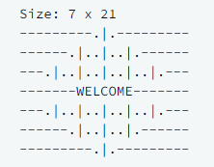

Input : First line is number of test cases, T and first line of each test case are space separated values N and M

Output:

Print the pattern for given N and M

15. There is a chess board of size NxN numbered 1 through N as shown. Only one queen is initially on the chess board at some location (x,y). Queen can make moves horizontally, vertically and diagonally. You are given with k pawns in order to restrict the queen’s moves. Output k lines with (x,y) coordinates for each pawn in decreasing order of priority in order to restrict the majority of moves.

Input : The first line of each test case is the number of test cases,T The first line of each test case is space separated values N, x, y and k

Output : k-lines for each test case with space separated values x and y of the pawns

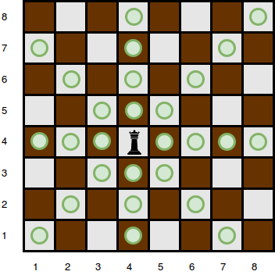

16. You are given N fingers per hand and length of each finger on the hand. There is a glove of n sheaths with lengths of each sheath given. You are allowed to switch sheath A and B if length of fingers

corresponding to A and B are that length of B is divisible by length of A. What is the maximum number of switches that can be made?

Note : A switch is valid only if the length of sheath corresponding to the finger is greater than or equal to the length of the finger after the switch is made.

Input : First line of input is number of test cases T

First line of each test is n

Second line of each test case is the space separated n values of finger lengths

Third line of each test case is the space separated n values of sheath lengths

Output: The maximum number of switches for each test case.

17. X has a farm with N cows and F units of fodder. Some cows are conscious about other cows watching them eat and therefore don't want to hog on their fodder. Suppose cow i is conscious, it is conscious

about cow (i-1) and cow (i+1) watching it eat. Cow i will eat 1 unit of fodder only if cow (i-1) and cow (i+1) eat (i*2) units of fodder together. Each cow is given 1 unit of fodder in the beginning. As and

when the cows finish the fodder, they are given the next unit. Assume same rate of eating for all cows.

Input : First line of input is number of test cases T

First and only line of each test case is the total number of units of fodder consumed by each cow

Output:

Output a series of 0s and 1s based on whether the cow is conscious or not. 0 for not, 1 for conscious.

18. You are given n rows and m columns of rooms in a particular floor of a building. There are x countries sending t teams each. We need to assign rooms to each team such that teams from the same country

are able to communicate with each other. Two teams can communicate if they share a common wall or team A and team C can communicate with each other if team A and team C can each communicate with team B.

Input : First line of input is number of test cases T

First line of each test case is space separated values of n and m

Second line of each test case is space separated values of teams Ti where i is the country such that Σ Ti = n*m

Output : Output the n*m matrix with space separation between columns and \n between rows where each cell of the matrix is the country i, satisfying the conditions mentioned above

19. You are given a word W(of n letters) in English and you are supposed to translate the given word to an imaginary language X(of m letters). It is known that length of word W is less than or equal to the length of word X. You are supposed to use letters of the word W and word X for the translation. For every valid i(starting with 0), the ith letter of W(say i1) is compared with the (m//n*i)th letter of X(say i2). Now, in the English alphabet, the letter that is at the middle of i1 and i2 for each i, is i3 which is the ith letter of the new

translation.

Input : First line is number of test cases,T First line of each test case is the word W Second line of each test case is the word X

Output: The translation of W in X

Ex:

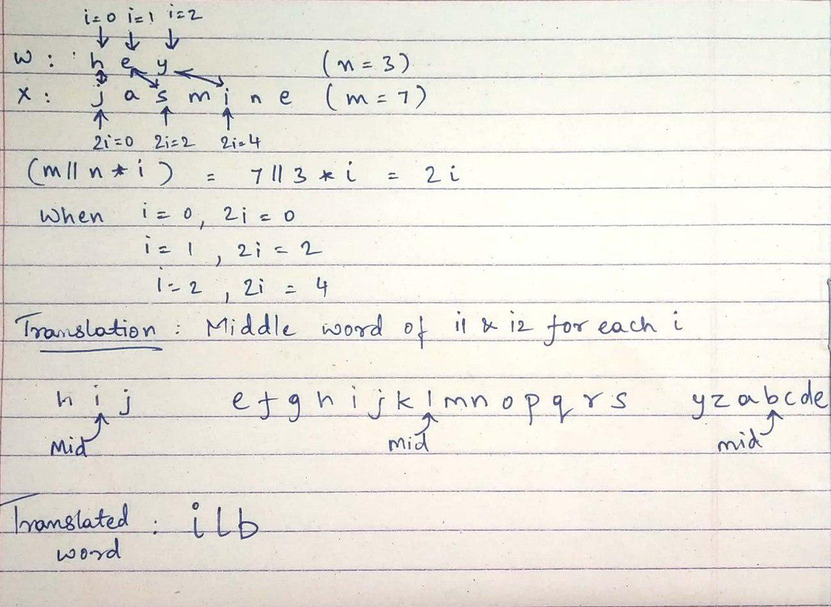

20. Lets rewind to 1940, the German military has been using the infamous encryption machine titled the Enigma to secure their communication, but it has just been cracked by the brilliant Alan Turing. You are entitled with the task of securely communicating army commands to battleships over the sea. The fate of Germany is in your hands. So you have decided to use the then newly made cipher, the Autokey Cipher to encrypt your information.

The Autokey cipher uses the following Tabula Recta to encrypt

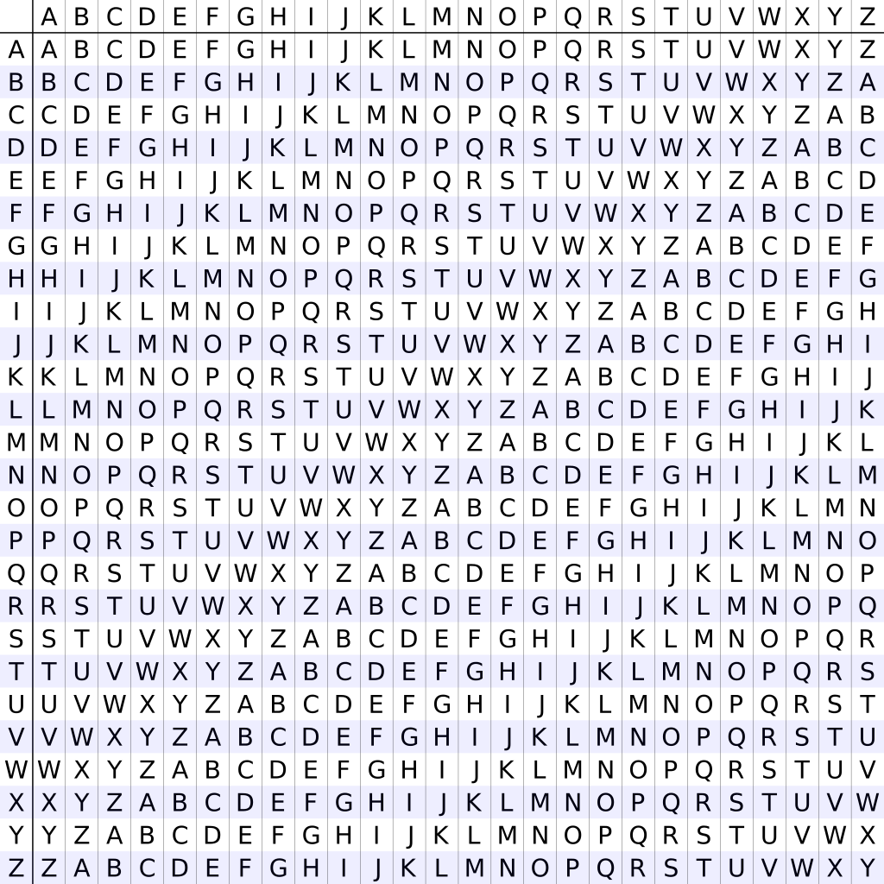

**ALGORITHM :**

To encipher a message, place the plaintext above the key. Once all of the key characters have been written, start writing the plaintext as the key:



We then use a Tabula Recta to find the keystream letter across the top, and the plaintext letter down the left, and use the crossover letter as the ciphertext letter. Now we take the letter we will be encoding, 'M', and find it on the first column on the tableau. Then, we move along the 'M' row of the tableau until we come to the column with the 'K' at the top, the intersection is our ciphertext character, 'W'. Continuing in this way we get the ciphertext "WMRZYIEMFLEVHYRGF".

The first line of input is T cases

The next line contains the keyword and the following line the plaintext

Given T cases and keys and plaintexts, output the ciphertext.

Example :

**Input**

2

KING

MEET ME AT THE CORNER

QUEEN

MISSION ABORT

**Output**

WMRZYIEMFLEVHYRGF

CCWWVAVSTWFG

21 . Marco makes YouTube videos but he does not have a microphone. He uses his earphone mic to record audio separately since his camera microphone is not good enough. In order to sync up the audio from the earphone mic in post, he claps N times so that the clap-sound is recorded in both the camera mic and earphone mic. Since he records videos outdoors, there is sound from vehicle horns that may be mistaken for clap-sound but recorded only on the camera mic. You are given with a string S with a combination of 0s and 1s which represent no-sound and sound respectively as recorded on the camera mic.